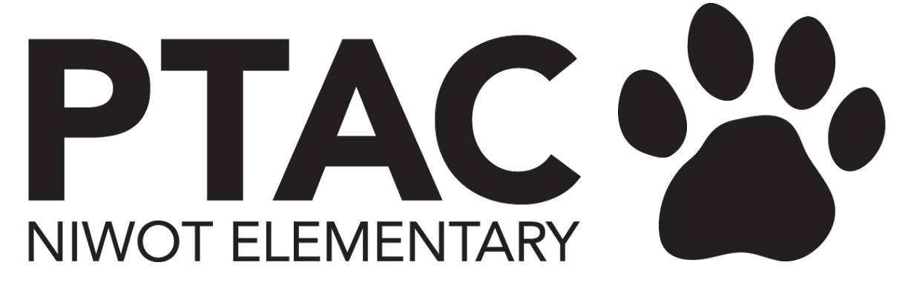
PTAC Board Meeting Agenda
October 2023

Welcome
Presentation by Mary Ellen Graziani, Assistant Principal of Sunset Middle School

- Mary Ellen - 20th year in district, has worked in many of the schools before going into admin
- Sunset -
  - Known for cultural diversity, and also Neurodiversity
  - Size (350 students)- small, close community, connected
    - Class sizes - 17-24
    - Electives - have bigger class sizes (i.e. band - 30+)
  - Unique programming
    - Middle Years program - all encompassing for all students
      - Follows state/district curriculum - 4 cores
      - Students work on cultural and community
      - International Baccalaureate (IB) curriculum - PE, music, visual arts, world languages, general electives (drama/theater, student council, robotics, etc)
        - Involves a capstone project - only middle school in the district that does
    - Schedule - Alternating blocks, with middle of the day “lab time” - can focus on needs of kids
    - Robust G&T program
  - Time: 7:35-2:30
  - Nov 2 - Elementary visit to Sunset, will also see Fall Musical
  - Nov 9th - 5th grades get tour of school, get intro to music program, station rotation - STEM, robotics,
  - Oct 26th - Open house - intro, station rotations, G&T, Special Ed, music, robotics, etc.

Principal Update
ITEMS TO BE DISCUSSED
- Hiring Update
  - Almost fully staffed
  - 5th grade - hired 8 hour/day para 8a-4:30p, really happy with new hire
    - New para will help across all 5th grade classrooms
    - 1 year position, based on class size
  - ASD classroom, hired 1, and still have 1 opening
  - New staff this year - we have new teachers this year, they are all doing a great job.
  - Paras - funded by PTAC, community funded
    - Gracie - Discovery Lab, Robotics, weekly newscast with 5th graders
    - 3 paras - 3 hrs/day - 1st-5th grade - strictly working with small group
- Academic Update
  - Celebrate last year’s CMAS scores
    - 5th (now 6th) - ELA - highest in district, 2nd hight in MAth
    - 3rd (now 4th) - highest in both in district
  - iReady
    - Top 2 in district for this year’s score
- John Erwin Award - school performance framework (state scored report)
  - Academic excellence award based on CMAS

President
ITEMS TO BE DISCUSSED
- Events
  - Trot final results
    - 609 participants
    - Still crunching expenses vs. income
  - Cougar Campaign - we are only 45% to our goal (see Fundraising section)
  - Watch DOGS - launched and running
    - Going well
    - Now calendar will be live for people to sign up for a second day
  - Talent Show - applications for all acts due Nov 3rd
    - First show offs Nov 14-15 - in music room
    - Second show offs Jan 17-18 - needs to be an act with costumes
    - Dress rehearsal Feb 1 - run through full show
    - Performance Feb 2
    - Committee meeting Oct 17th to kick off planning - 7pm-8pm at Fritz Brewery
  - Cougar Carnival - date has been finalized: Friday, May 10th! Molly to reach out to new Carnival committee to schedule kickoff informational meeting with Ashlee Tabolt (last year’s chair)
    - New team
    - Molly to put together a meeting for the new committee with Ashlee to get all the info from past years
- Thoughts on holiday gathering for volunteers and Board?
  - For board and volunteers - social - early December - maybe Thursday 12/7
- Ideas for a thank you for Colleen and Amiee - from all their work from the Trot
  - Massage, pedicure, flowers at end of event
- Next years trot
  - need a volunteer dedicated to sponsorship
  - Need to create full “how to” documentation

Treasurer
ITEMS TO BE DISCUSSED
- Finalizing bank merger transition to BMO online and Quickbooks re-integration
- September financials are pending update to Quickbooks integration
- YTD expenses are consistent with the budget
  - No final trot numbers yet, but we think it raised more than we expected
  - Venmo was running for the trot - to take payments - however not make payments
    - Venmo connected to Maggie’s personal account - will need to figure out transition eventually

VP Fundraising
ITEMS TO BE DISCUSSED
- Cougar Campaign
  - Still down more than we wanted to be
    - Maybe some fundraising fatigue after so many events
  - Backpack tags to be stapled on Weds 10/18 at 9:15a - volunteers to help after drop off
    - Sarah, Emily, Molly
    - Teachers will be aware
    - Announce Nancy’s Challenge - CHICKEN FOR A DAY
      - Announce this week
      - wear chicken costume all day - inflatable vs. other - lead chicken dance at the end of the day, lay a golden egg
    - Raffel - for all who have donated
      - Communicate - shout points - raffel and para stories
      - Prizes - Niwot swag, Spiritwear gift card
      - Reconvene on when/where
      - 4 Fridays left
        - Will need to extend if we don;t meet the goal
        - Deb Fowler - CO Landmark - match? But - this was more likely for Trot

- Dining for Dollars
  - Protos tonight
  - Proposed Name Change - by Committee
    - Logic - there are other $$ raising opportunities
      - Ie - Get Air
    - Community Nights
- Misc Parent Questions
  - Request for Cougar Paw car bumper magnets
    - Shipping was more on Spiritwear site then the magnet
    - Is there a way to bulk order?
    - Maybe invest in as a giveaway
  - Possible NES parent business google doc
    - Parents could choose to add their business
    - To be used as a local resource, non-endorsed
      - Concerns - who would manage/administer it?
      - Maybe a slippery slope
      - Possibly to be connected to PTAC website
  - PTAC movie morning on late start days
    - Would need to have staff connected to it, but on late start days - staff is in meetings
    - Potentially with PTAC volunteers
    - Issues with Cougar Club licensing

Secretary
ITEMS TO BE DISCUSSED
- Status of Teacher Grants
- Grant Request from Miss Gracie in Discovery lab - total is $51.66
  - Approved
- Gracie - never requested $ for a camera
  - Maggie - idea - Can we put in newsletter request for a camera donation
    - Sarah - help with blurb for camera donation (Thursday)
- Colleen - Send out Grant Request today

Photos from Trot - Cannot do a mass share with school community
Next year - have people sign a photo waiver next year & liability waiver

Communications
ITEMS TO BE DISCUSSED
- Ideas to boost Cougar Campaign? Dollars raised as of 10/9/23: $26,918.77 (45% to goal)
  - We have testimonials from Regan Burke and Gracie Winka that we can send out
  - Nancy challenge? Raffle?
  - Shout points/flyers/ backpack tags
  - Posters to highlight corporate matching
  - What’s not working? Other ways to incentivize?
- I will get a calendar prepped and sent out with dates for upcoming PTAC meetings

Volunteer Coordinator
ITEMS TO BE DISCUSSED
- If you hear of anyone - teachers - that need volunteers - send them to Emily
- Parents seem to have easier time with Signup Genius compared to spreadsheets
- Brownski - who currently heads up the food/hospitality volunteers - have about another year

Next Meetings
November - Mon, Nov 6th at 6pm (via Zoom)
December - Tues, Dec 12th at 9:15am
January - May meetings to be scheduled in December

