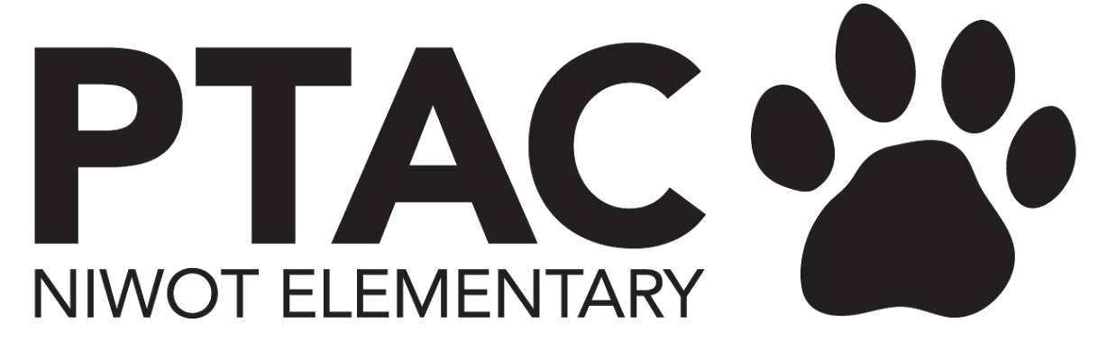
PTAC Agenda November 2022
BOARD MEETING Agenda

Principal
- Updates
- Drive Thru Career Fair

President
ITEMS TO BE DISCUSSED
- Winter Book Fair 12/9-12/16
- Kids doing decor,
- Spreadsheet coming for volunteer sign up
- Black tablecloths for purchase for PTA
- Add color with decor, green signs
- Decorate wall in front of library 12/1
- Set up book fair 12/8
- Consider add a time during the day for parents to shop without kids

Treasurer
ITEMS TO BE DISCUSSED
- Ms. Mocilac art room supply request pending approval $200 - This is approved, waiting on links from Ms. Mocilac
UPDATES
- Updated financial statements are posted to the PTAC website as of 10/31/22
- Approximately $6,100 has been disbursed from the surplus
- Square skate, recess equipment and concert t-shirt materials have been approved and are all pending reimbursement forms or invoices to be paid (Approximately $3,100 combined)

Exploring Careers through vehicles - part of school counseling
- Focus on career interest
- May 3, 2023
- Vehicles - set up outside, each one will have a little talk
  - Needs:
    - Ambulance
    - Food Truck
    - Mobile Dog grooming/Vet
    - Video Gamer/ youtuber
    - Soccer/Football player
    - Piolet
  - Haves: engineer, scientist, military, police, fire, innovation lab, farm vehicle
- Help kids understand that there are various career opportunities with various industries and how their interests can expand and change. Ex: Accountant for vet clinic

VP Fundraising
ITEMS TO BE DISCUSSED
- None
UPDATES
- Talent Show will take place on March 31st (dress rehearsal on March 30th). Theme and event timeline are in process.
- Cougar Campaign raised @ $51k! Thank you everyone for your support!
- Dining for Dollars
  - Oct - Chipotle - $828.81 (which is more than last year in Spring!)
  - Nov - Proto’s - check is coming to PTAC this week
  - Dec 6th 5-8pm - Culvers - 10% of all sales dine and drive thru - no code needed

Secretary
ITEMS TO BE DISCUSSED
- Grant Program
UPDATES
- Balog - Skateboard program - approved
  - What’s the date?
- Maciloc - Art room equipment - approved
- Madry - 2nd grade costumes - approved
- Larson - 1st grade supplies - to be voted
  - Questions - For all of 1st grade? Have you used your gift card?

Communications
ITEMS TO BE DISCUSSED
- Schedule/communication for Cougar Campaign reward?
  - TBD by Nancy
- Communication for Book Fair
- Update list of Teacher Appreciation Gift Ideas on website? (add new teachers, remove old teachers, update current teachers) (helpful for families for holiday gift ideas)
  - Teachers update - and list of likes/wants
- Upcoming events/other communication needs?
UPDATES
- Awesome Cougar Campaign!

Nancy -
- Ice cream sundae reward - weather dependant - have to do it outside - try in December
  - Do it at end of day
  - Rain ponchos, goggles
  - Popicles - have them here and let teachers grab them for students - store in kitchen - Purchase at Sam’s Club
- Teacher Appreciation - Sarah to put together email and google form - send link to Nancy and then update website
- Grants - going well
- Young Ameritowne - families volunteer to help donate for kids that need it
- Cougar Campaign sign to come down over TG break
- Career fair - sounds great
- Book Fair
  - No “parents only” shopping time
  - Sarah - Save the date for the Book fair
- Cougar Campaign - Sarah - blurb for newsletter - that we met the goal and the sundae is coming

Volunteer Coordinator
UPDATES

Next Meeting

