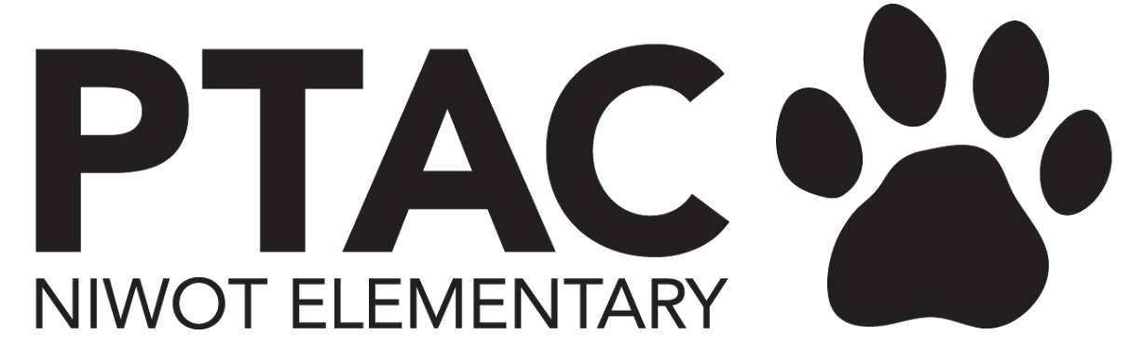
PTAC Board Meeting Agenda
January 24, 2024

Welcome
Attendees: Molly, Sarah, Emily, Emily Inman, Carly, Nancy

Principal Update
ITEMS TO BE DISCUSSED
- Valentine’s Day
  - Parties are going to happen on Weds 2/14, everyone will celebrate at the end of the day but 1st grade will celebrate before specials
  - Just room parents in the classroom for safety control
- Learning Celebrations w/ Book Fair & Mwebaza Art Show
  - Tues 2/6, Weds 2/7, Thurs 2/8 4pm-7pm
  - Kelly Bronski is spearheading signups for food for teachers during this
- Library Update
  - Ms. Kelly wants to do this design project through the district, Nina Starks (4th grade teacher) did this same project at a different elementary school and is a big supporter for this
  - There will be changes over the next few months
  - Only downfall of doing this now instead of waiting until next year with such a quick turnaround we did not get to get the voices of students and parents for this first step (didn’t want to risk not getting the funding for it if we waited until next year)
- Teacher of the Year
  - In the newsletter, and on NES facebook page, Sarah will add info to PTAC facebook page (QR code is in newsletter)
- Attendance
  - If our kids are not here, we can’t teach them
  - If someone is chronically absent (missed more than 10% of school year), currently NES attendance rate is 95.40%, one of the higher ones in the district! (a year ago at this exact time we were at 93.87%, increase of 1.53%, 70 kids chronically absent last year, this year is only 30 kids - 10.35% increase)

President
ITEMS TO BE DISCUSSED
- Events
  - Talent Show
    - We have 50 acts this year, including teacher act and 5th grade act.
    - Dress rehearsal is Feb 1 and performance is Feb 2. On Feb 2, I have Sarah helping backstage, Carly selling flowers, and Emily helping with TBD.
      - Anne and Sue are doing ticket sales (5th grade and under is free and everyone else is $5 each)
      - Can we accept credit cards and venmo
      - Anne is picking up flowers
      - Helpers arrive by 5:30p, decorating arriving at 4:30p, starts at 6pm will probably go until 8:30p
      - High School is selling concessions
      - A debate will be happening at the same time in the gym
    - Gracie will be onsite on Feb 1 to get photos for the yearbook
    - The Left Hand Valley Courier editor is interested in covering this event and more for NES
      - ‘Niwot Kids Got Talent’ this year theme ‘24 Karat Gold’ Kids write this and Molly will edit
      - PTAC communication can start being sending to this contact throughout the year
    - Opening to talent show: after Ms. Pitz remarks, Bruno Mars inspired poem will be read and then 20 acts will come on the stage for a quick opening dance
    - Need an updated program cover from Sarah to include this year’s dates
    - Emily Inman to put out a shout point on Weds 1/31 - include ticket sales info

  - Book Fair Feb 5-9
    - Julie Cook is chairing it.
    - Emily getting volunteer Signup Genius out this week. Setup is on Feb 2 (talent show day!!) - 3 volunteers are signed up
      - Emily will send signups directly to teachers with grades with low volunteer sign up
      - Sign up is on facebook
  - Cougar Carnival
    - Event co-chair is Renee Heinz
    - Had debrief with Ashlee and planning has kicked off!
    - I will be sending out a short survey to get parent feedback.
    - Can we make a list of inventory that we have
    - Find a way to have more people contribute to it
      - games per classroom (could use hallway space, but tricky to use actual classrooms)
      - maybe a discovery lab stem game
- AFW School Rewards program - did this get settled?
  - Have placed a tile of info on the front page of PTAC website
  - Do we want to put this on facebook? - don’t typically promote there
  - Newsletter - lengthier graphic or shorter blurb - put bigger graphic in newsletter for a week or two and then move down to the shorter blurb
- February social gathering for volunteers and Board - maybe a Valentine's theme. Need to pick a date.
  - Molly will send doodle for dates, either at Molly’s or out at a place, couple hours on a week day

Treasurer
ITEMS TO BE DISCUSSED
- Financial statements have been updated through 12/31/23 (sending to Sarah 1/23 to post to website)
- Para cost variance should be ok within constraints of our budget considering other proceeds/spending levels. I will prepare a detailed variance analysis prior to our next meeting.
  - It would be nice to leverage some additional fundraising to maintain reserves moving forward, but not urgent
    - Staff (Teacher/Para) Oriented Silent Auction Experiences - Sarah, Carly and Meg Tufo to begin planning this - auction items end of March/beginning of April - leave 1 month of time for items to be redeemed
- The connection between Quickbooks and the bank has failed again as of mid-January. I will work to resolve it before the end of the month.

VP Fundraising
ITEMS TO BE DISCUSSED
- Dining for Dollars
  - The Get Air/DQ night in January generated $255.68 - not bad for falling on a cold winter date. The actual from Bad Daddy’s was $465 (the $1k amount was an error from the manager)
  - To date Dining for Dollars has brought in $1791. This is $234 less than where we were in 2023 at $2025
  - Upcoming spring dates/locations:
    - Feb - Tues 2/6 at Culvers from 5pm-8pm (providing a quick drive through dinner solution for parents/teachers during learning celebrations) - 10% back from all sales
    - March - Weds 3/6 at Urban Field Pizza 4pm - 8pm - 10% back from all sales
    - April - (Is this date change okay instead of Tues 4/2?) Weds 4/3 at Chipotle 4pm-8pm - 25% back on all Niwot mentioned purchases
      - This is during CalWood for 5th grade
      - See if we can switch to Weds 4/17
      - Not 4/28 - concert choir
    - May- (Is this date change okay instead of Tues 5/7?) Thurs 5/9 at Oscar Blues, donate portion of full day sales, waiting to hear the %
      - 5/9 is the day before the cougar carnival - see if Thurs 5/16 is available
      - 5/14 is all school field day, 4/30 is 5th grade field day
- Paw Magnets!
  - Have arrived and are for sale in the main office for $8 each. Payment can be made by Venmo or check.
  - Are we okay offering these for sale at the Talent Show also? (25 magnets have been placed out (approx 10 have sold) and 25 are in backstock) - also sell Trot Hats $10 each
- Other Funds Generation
  - American Furniture Warehouse
    - Check with Maggie if we received check payment this year
  - Sprouts School Supplies - lots of emails about these programs, has PTAC ever tried? - haven’t proven to raise very much
  - Spiritwear - get contact info from Molly and promote sale of spiritwear
- Misc
  - BMO is mailing a debit card in Carly’s name - should arrive to NES by end of next week
  - Who prints field day shirts - probably Emily and Baylog

Secretary
ITEMS TO BE DISCUSSED
- No pending grants at this time

Communications
ITEMS TO BE DISCUSSED
- AFW School Rewards program - let’s discuss comms for this
- Can we get someone to help Renee with Cougar Carnival?
- Facebook page engagement is really low - ideas?
  - Does it make sense to switch platforms - are people using Instagram more. Are people using Threads?
- Update on Cougar Campaign school reward?
  - Waiting until it gets warmer

Volunteer Coordinator
ITEMS TO BE DISCUSSED

Next Meetings
February - May meetings in process

