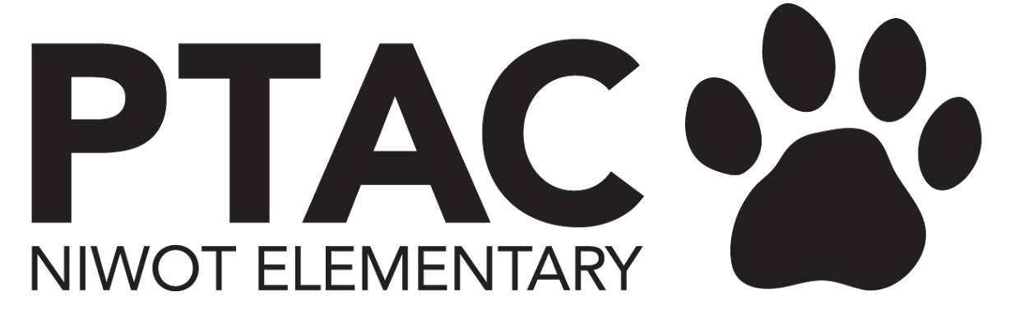
PTAC Board Meeting Agenda
February 2024

Welcome

Principal Update
ITEMS TO BE DISCUSSED
- 11:45am - deadline for Encore/Teacher of the Year Nomination
  - Sarah to add to FB today
  - Emily to send shout point
- Great Schools review
  - Site that our families go to - www.greatschools.com to share reviews
  - This is where realtors and new families go to
  - Its important to have lots of good reviews
- Update on Silent Auction from staff
  - PTAC does not pay for auction item
  - Examples: Games and snacks, CO Rockies game
  - Staff is in - did not have expectation for PTAC paying for it
- Kazu Kibuishi visit 03/05/2024
  - Author - event coming up, super excited about - 3/5/24 - big deal, working with the publisher
  - For 3rd-5th
  - Author is also speaking at Boulder Library same night - need reservations.
  - District Communications coming to cover it
  - Left Hand Courier to publish an article - maybe with student reporter
  - Heather (Comm director) can reach out to Longmont Times Call - “pitch it”
  - Probably a press kit from the publisher
  - District tech dept will come to help
- Book Fair - $16K - largest grossing ever
  - Sales tax - a little more than we expected
- 24-25 Para Estimate/Request
  - Signing to begin process with district - requesting estimates from the district - form to approve to get estimate
  - Staffing plan after approval
  - In April for PTAC - Molly & Maggies work together to figure out budget - and in May PTAC votes on budget
    - Final number not solidified until August - depending on paras taking benefits, etc.

President
ITEMS TO BE DISCUSSED
- Events
  - Talent Show debrief
    - Ended up breaking even
      - Cost of auditorium was expensive
      - Doubled flowers to sell - but only sold half
      - Kashia (Maren’s Mom) will head the talent show next year
      - Cody will take production role
  - Book Fair debrief
    - See above -
    - 120 copies of book 1 & 9 of Amulet were sold
  - Cougar Carnival Update
    - Will need extra custodial
    - Renee is working on it
    - Ms. Gracie thinking about getting students involved in planning games. Maybe get Ms. Mocilic involved
- Time to think about planning for next year
  - Molly to start chatting with everyone about roles - start thinking about succession planning
- Social gathering for volunteers and Board - pushed due to overload

Treasurer
ITEMS TO BE DISCUSSED
- Talent show - breaking even or close to

VP Fundraising
ITEMS TO BE DISCUSSED
- Dining for Dollars - finalized dates for spring
  - Weds 3/6 - Urban Field Pizza
  - Weds 4/17 - Chipotle
  - Thurs 5/16 - Oskar Blues
- Sweet Cow Truck donates 40% - can we get them for carnival?
  - Molly to contact and make it happen
- End of School - Mwebaza fundraiser with Kona
- Silent Auction
  - Launch online auction last week of March/1st week of April
    - Don’t make it too long - maybe 3 days of previews, short time for bidding
    - Make posters of all the experiences - and hang up in the cafeteria
      - Can be easy, homemade - type posters, maybe Gracie can help
    - Announce them in mornings
    - Consider technologies for some families - maybe set up a universal computer
  - 1 month to redeem items from 4/15 - 5/15
    - Timing good with CMAS testing (4/8-19, week of 22nd makeups)
  - 32auctions.com for online platform - trying to get past login info
    - Unknown old info
    - *****Use galabid.com****
  - Revenue goal
  - Sarah - considerations for advertising - careful not to spend money
    - Teachers give a presentation - provided by PTAC - to talk it up to kids
    - Lets have teachers do the presentation in the classrooms.
    - Committee to flush out dates
- Google form for participating teachers/staff to fill out
  - Okay for teachers/staff to fund their experiences
  - Nancy to start prepping
  - Send out form sometime next week - and teachers will have until 3/11 so the deck is prepped before spring break. Deck ready 4/1
  - Launch Monday 4/1
  - Remind 9th & 10th
  - Open for bidding 4/10-12
- Burlington Elementary - struggling for funding
  - There is a history within the district “adopting” a school
  - Does it have to be financial - could it be a book drive or something?
  - We don’t need an answer now - but something to consider.

Secretary
ITEMS TO BE DISCUSSED
- No updates

Communications
ITEMS TO BE DISCUSSED
- Working silent auction tasks with Carly
- Working with Left Hand Courier. I can send the images/flyers I create, but other ways to communicate with them? Copies of the newsletter?
- Created an Instagram account for the PTA! https://www.instagram.com/niwotptac/
  - Do we want to keep the page public or private?
    - Will impact if we can crosspost across Facebook or not. Confidentiality/privacy concerns for families/kids?
    - For now will post in both - keep both separate and private
    - Insta - highly visual - photos would be great, but there are some families that dont allow photos of kids
  - Highly visual platform - would be great if we could post photos here.
    - May be time consuming to check who allows this
    - Work with Gracie?

Volunteer Coordinator
ITEMS TO BE DISCUSSED

Next Meetings
March - May meetings in process - have you filled out the Doodles?

