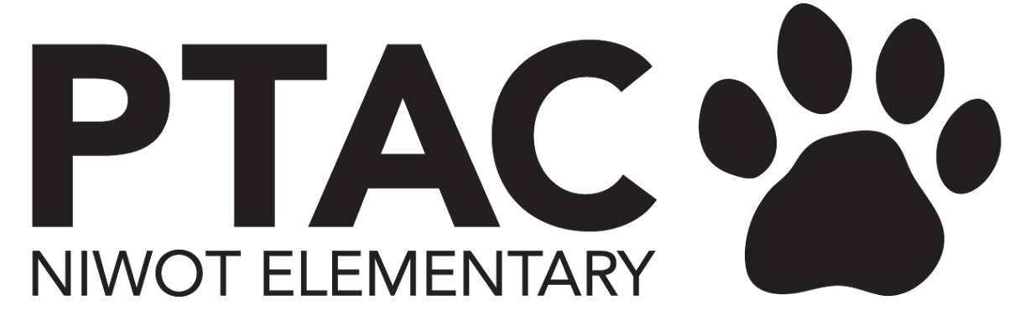
PTAC Meeting Notes January 2023
BOARD MEETING

Regan Burke
- Is accepted into a literacy cert program areas of focus are - literacy fluency, dyslexia, multisensory approach
- District paying for tuition, 18 month training
- Ask - $850 for student curriculum to implement learnings into daily literacy activities
  - Kit is for “Year 1” - program ideal for 7 year olds, but can be shifted up or down for all grade levels.
- Decision by later this week

Kelly Blackford
- Wandering Jellyfish now does book fairs - Mid to late April
  - % profit is tiered - we would likely meet max based on past book fairs
  - They have registers and all the stuff to easily implement
- Idea for March - Tournament of the books - march madness style with brackets
- Weekly reading challenge on top of bracket
  - Meet criteria - earn # of shots, earn prices
- ASK: Needs 1 person to help with working out details - Molly volunteered
- Needs financial support - maybe about $500
  - Grant application would be best instead of earmarked $$ for books
- “Library Refresh” - before district will allow a complete refresh - will need volunteers for training and weeding
  - Colleen, Monet, Sarah happy to help

VP Fundraising
- Talent Show
  - Committee Chairs: Liz Napp & Molly Walsh. Sue Pearson joined committee. We will need volunteers - working on job list
  - Deadline for application to participate is Feb 1st
    - First show offs Feb 8-9
    - Second show offs March 15-16
    - Dress rehearsal March 30
    - Talent Show performance March 31
- Marketing: Sarah helping by creating flyers & poster design which will go up Thurs. We will also send a shout point parent reminder + deck for teachers to help educate kids on what this event is. All kids will get a flyer.
- 13 acts so far, Deadline 2/1
- Blurb to send out again this week - Friday

President:
- Carnival:
  - Can it be free again this year? Will the carnival be free again treasurer@niwotptac.org, what were the numbers last year, do you think we can swing it again this year, anticipating more people this year?
    - NEEDS VOTE BY NEXT WEEK
      - Difficult thing to continue with no cost - going forward - maybe $5
  - Food Trucks
    - Probably need 3 savory food trucks instead of just 2
    - All were in favor of having food trucks
  - Kona - not necessary
    - Do we need to have Kona? Ashley suggested https://www.bigwheelbeverages.com/about, I support this suggestion.
  - treasurer@niwotptac.org did payments run smoothly, any reason to try something else?
  - Cakewalk - was a great success - increase this year
  - Do we need to sell NES gear? I say no and am in favor of having a “fire sale” when the weather gets warmer.
    - Give some NES wear to staff
  - Mwembaza - will do their own thing
  - Prizes - needs better organization

Career Fair
- Izzy - needs survey at beginning of year for Career fair
- Need gamer and and athlete - like football or basketball
- Will be on black top and bus loop
- Izzy will provide blurb to Sarah for FB communication - helping find people, possibly for volunteers - but event is NOT for parents

Nancy:
- Lauren Mocilac - Meow Wolf 4th grade - End of Feb.
  - Can PTAC contribute $$ ($1000)?
  - Bus, entrance $15
  - May need to have parents cover partial cost of entrance
- School Supplies
  - We’ve done it to simplify it for families, but do people need/want it?
  - Nancy says - SCRATCH IT
- New Discovery Lab Teacher
  - Can we gift her a $150 Amazon Gift Card? NO - she should do a grant instead for anything needed.
- New Attendance Clerk hired
Dining for Dollars:
- NES Chiplote overlaps with Mwebaza Chipolte - need to check into that
- Dining For Dollars - they track their progress in this spreasdsheet. Need totals & confirmation of $ received for Proto’s (Nov)

Opera:
- Colleen: to have Boulder Opera Company education outreach person come to next meeting - hopefully also have Mrs. Madry get involved about in school performance

Items from Agenda not discussed

President
Volunteer Appreciation event
Ideas?
Please start thinking about if you plan on staying on the board for next year, I hope you stay!

Treasurer
Financial statements through December 31, 2022 are posted to the website
Surplus spend = $6,401.38
Approved but not yet paid:
$1,800 Square Skate
$230 2nd grade concert shirts
Placeholder requests:
$500 recess equipment
$200 art room supplies

Dining for Dollars received YTD:
Chipotle = $828.81
Protos = $375

Pending payments = Scholastic book fair taxes + Q2 paras

2022 Cougar Carnival spend = ~$6K (no issues regarding payments)

Next Meeting

